SETUP ACCOUNTING

1. Add account type

* Navigate ROOT\OpenWay\Full\Configuration Setup\Accounting Setup\Account Types
* Click “Insert new record”
* Input values
  + Product: Bank Accounting
  + Name: Mics Acc BTC
  + Account Role: Settlement
  + Category: Other
  + Is Am Av: No
  + Due Type: None
  + Code: M_CBT
  + Priority: 0
* Click “Save form changes”
* Click “Insert new record”
* Input values
  + Product: Bank Accounting
  + Name: Incoming Active Chargeback – JCB
  + Account Role: Settlement
  + Category: Other
  + Is Am Av: No
  + Due Type: None
  + Code: t_chback_jcb
  + Priority: 0
* Click “Save form changes”
* Click “Insert new record”
* Input values
  + Product: Bank Accounting
  + Name: Incoming Active Chargeback – MC
  + Account Role: Settlement
  + Category: Other
  + Is Am Av: No
  + Due Type: None
  + Code: t_chback_mc
  + Priority: 0
* Click “Save form changes”
* Click “Insert new record”
* Input values
  + Product: Bank Accounting
  + Name: Incoming Active Chargeback – NAPAS
  + Account Role: Settlement
  + Category: Other
  + Is Am Av: No
  + Due Type: None
  + Code: t_chback_napas
  + Priority: 0
* Click “Save form changes”
* Click “Insert new record”
* Input values
  + Product: Bank Accounting
  + Name: Incoming Active Chargeback – VS
  + Account Role: Settlement
  + Category: Other
  + Is Am Av: No
  + Due Type: None
  + Code: t_chback_vs
  + Priority: 0
* Click “Save form changes”
* Click “Insert new record”
* Input values
  + Product: Issuing
  + Name: Open Sale Interest
  + Account Role: Loan Interest
  + Category: Other
  + Is Am Av: No
  + Due Type: End Cycle Due
  + Code: POC_OSI
  + Priority: 0
* Click “Save form changes”
* Click “Insert new record”
* Input values
  + Product: Issuing
  + Name: Open Cash Interest
  + Account Role: Loan Interest
  + Category: Other
  + Is Am Av: No
  + Due Type: None
  + Code: POC_OCI
  + Priority: 0
* Click “Save form changes”

1. Add GL account plan

* Navigate ROOT\OpenWay\Full\Configuration Setup\Accounting Setup\GL Account Plan
* Click “Insert new record”
* Input values
  + Name: Phi the tin dung chua thu duoc (9410) – NEW
  + GL Type: Balance
  + GL Number: VND194441100.BBBB
  + Currency: VND
  + Institution: ORIENT COMMERCIAL BANK
* Click “Save form changes”
* Click “Insert new record”
* Input values
  + Name: TK Chargeback MC
  + GL Type: Balance
  + GL Number: VND1754310010001
  + Currency: VND
  + Institution: ORIENT COMMERCIAL BANK
* Click “Save form changes”
* Click “Insert new record”
* Input values
  + Name: TK Chargeback JCB
  + GL Type: Balance
  + GL Number: VND1754410010001
  + Currency: VND
  + Institution: ORIENT COMMERCIAL BANK
* Click “Save form changes”
* Click “Insert new record”
* Input values
  + Name: TK Chargeback NAPAS
  + GL Type: Balance
  + GL Number: VND1754710010001
  + Currency: VND
  + Institution: ORIENT COMMERCIAL BANK
* Click “Save form changes”
* Click “Insert new record”
* Input values
  + Name: TK Chargeback VS
  + GL Type: Balance
  + GL Number: VND1754610010001
  + Currency: VND
  + Institution: ORIENT COMMERCIAL BANK
* Click “Save form changes”
* Click “Insert new record”
* Input values
  + Name: TK Cashback
  + GL Type: Balance
  + GL Number: VND1260110120001
  + Currency: VND
  + Institution: ORIENT COMMERCIAL BANK
* Click “Save form changes”
* Click “Insert new record”
* Input values
  + Name: TK Phai thu cho chuyen tra du co
  + GL Type: Balance
  + GL Number: VND1252910020001
  + Currency: VND
  + Institution: ORIENT COMMERCIAL BANK
* Click “Save form changes”
* Click “Insert new record”
* Input values
  + Name: TK Misc
  + GL Type: Balance
  + GL Number: VND1757610010001
  + Currency: VND
  + Institution: ORIENT COMMERCIAL BANK
* Click “Save form changes”

1. Setup event type

* Navigate ROOT\OpenWay\Full\Configuration Setup\Products\Event Types
* Insert new record
* Input values
  + Product: Issuing
  + Contract: Account
  + Institution: ORIENT COMMERCIAL BANK
  + Name: Transfer OVD To Provision
  + Code: MOVE_OVD_2_PROVISION
  + Duration Type: Unique
* Click “Save form changes”
* Action > Check
* Insert new record
* Input values
  + Product: Issuing
  + Contract: Account
  + Institution: ORIENT COMMERCIAL BANK
  + Name: Transfer Int & Fee OVD To Provision
  + Code: MOVE_FI_OVD_2_PROVISION
  + Duration Type: Unique
* Click “Save form changes”
* Action > Check

1. Setup transaction type

* Navigate ROOT\OpenWay\Full\Configuration Setup\Transaction Types\Transactions - All
  1. Balance Transfer
* Click “Insert new record”
* Input values
  + Service Class: Transaction
  + Source: Account
  + Target: Account
  + Name: Balance Transfer
  + DR~\CR: Debit
  + Chain Type: Original
  + Is Authorized: Never
  + Is Required: Yes
  + Category: Individual
  + RBS Code: BT
  + RBS Rev Code: bt
* Click “Save form changes”
* Click “Msg Types” 🡪 Open “Msg Types for …” form
  + Click “Insert new record”
  + Input values
    - Channel: Affiliated
    - Name: Balance Transfer To Account
    - Code: BTACC
    - Category: Advice
    - Is Authorization: Fin
  + Click “Save form changes”
  + Click “Insert new record”
  + Input values
    - Channel: Affiliated
    - Name: Balance Transfer To Card
    - Code: BTCARD
    - Category: Advice
    - Is Authorization: Fin
  + Click “Save form changes”
* Click “Sub Types” 🡪 Open “Sub Types for …” form
  + Click “Insert new record”
  + Input values
    - Source Cat: Account
    - Target Cat: Card
    - Source Type: Bank Account
    - Target Type: OCB MasterCard Cards
  + Click “Save form changes”
  + Click “Insert new record”
  + Input values
    - Source Cat: Account
    - Target Cat: Card
    - Source Type: Bank Account
    - Target Type: OCB JCB Cards
  + Click “Save form changes”
  + Click “Insert new record”
  + Input values
    - Source Cat: Account
    - Target Cat: Card
    - Source Type: Bank Account
    - Target Type: OCB Local Cards
  + Click “Save form changes”
  + Click “Insert new record”
  + Input values
    - Source Cat: Account
    - Target Cat: Account
    - Source Type: Bank Account
    - Target Type: Client Account
  + Click “Save form changes”
  1. Payment To OCB Contract – Chargeback
* Click “Insert new record”
* Input values
  + Service Class: Transaction
  + Source: Account
  + Target: Account
  + Name: Payment To OCB Contract - Chargeback
  + DR~\CR: Credit
  + Chain Type: Original
  + Is Authorized: Never
  + Is Required: Yes
  + Category: Individual
  + RBS Code: PTNCHBACK
  + RBS Rev Code: ptnchback
* Click “Save form changes”
* Click “Msg Types” 🡪 Open “Msg Types for …” form
  + Click “Insert new record”
  + Input values
    - Channel: Affiliated
    - Name: Payment To Account
    - Code: PAYTACC_CHBACK
    - Category: Advice
    - Is Authorization: Fin
  + Click “Save form changes”
  + Click “Insert new record”
  + Input values
    - Channel: Affiliated
    - Name: Payment To Card
    - Code: PAYTC_CHBACK
    - Category: Advice
    - Is Authorization: Fin
  + Click “Save form changes”
* Click “Sub Types” 🡪 Open “Sub Types for …” form
  + Click “Insert new record”
  + Input values
    - Source Cat: Account
    - Target Cat: Card
    - Source Type: Bank Account
    - Target Type: OCB MasterCard Cards
  + Click “Save form changes”
  + Click “Insert new record”
  + Input values
    - Source Cat: Account
    - Target Cat: Card
    - Source Type: Bank Account
    - Target Type: OCB JCB Cards
  + Click “Save form changes”
  + Click “Insert new record”
  + Input values
    - Source Cat: Account
    - Target Cat: Card
    - Source Type: Bank Account
    - Target Type: OCB Local Cards
  + Click “Save form changes”
  + Click “Insert new record”
  + Input values
    - Source Cat: Account
    - Target Cat: Account
    - Source Type: Bank Account
    - Target Type: Client Account
  + Click “Save form changes”
  1. Payment To OCB Contract – Cashback
* Update values
  + Category: Individual
* Click “Save form changes”
  1. Mics Trans Debit (SOA)
* Click “Msg Types” 🡪 Open “Msg Types for …” form
  + Select “Topup From Account”
    - Category: Advice
  + Select “Topup From Card”
    - Category: Advice
* Click “SubTypes” 🡪 Open “SubTypes for …” form
  + Select each records
    - Fee Algorithm Options: Empty
  1. Mics Trans Credit (SOA)
* Click “Msg Types” 🡪 Open “Msg Types for …” form
  + Select “Topup To Account”
    - Category: Advice
  + Select “Topup To Card”
    - Category: Advice
* Click “SubTypes” 🡪 Open “SubTypes for …” form
  + Select each records
    - Fee Algorithm Options: Empty

1. Setup service pack

* Navigate ROOT\OpenWay\Full\Configuration Setup\Products\Service Packs
  1. Teller Svc
* Select “Teller Svr” & Click “Source” 🡪 Open “Source for …” form
  + Balance Transfer
    - Click “Insert new record”
    - Input values
      * Target Type: Client Account
      * Transaction Type: Balance Transfer
      * Rate Type: Middle
      * Account Type: Mics Acc BTC
    - Click “Save form changes”
    - Click “Insert new record”
    - Input values
      * Target Type: OCB MasterCard Cards
      * Transaction Type: Balance Transfer
      * Rate Type: Middle
      * Account Type: Mics Acc BTC
    - Click “Save form changes”
    - Click “Insert new record”
    - Input values
      * Target Type: OCB Local Cards
      * Transaction Type: Balance Transfer
      * Rate Type: Middle
      * Account Type: Mics Acc BTC
    - Click “Save form changes”
    - Click “Insert new record”
    - Input values
      * Target Type: OCB JCB Cards
      * Transaction Type: Balance Transfer
      * Rate Type: Middle
      * Account Type: Mics Acc BTC
    - Click “Save form changes”
  + Mics Trans Credit (SOA)
    - Click “Insert new record”
    - Input values
      * Target Type: Client Account
      * Transaction Type: Mics Trans Credit (SOA)
      * Rate Type: Middle
      * Account Type: Incoming Active
    - Click “Save form changes”
    - Click “Insert new record”
    - Input values
      * Target Type: OCB MasterCard Cards
      * Transaction Type: Mics Trans Credit (SOA)
      * Rate Type: Middle
      * Account Type: Incoming Active
    - Click “Save form changes”
    - Click “Insert new record”
    - Input values
      * Target Type: OCB Local Cards
      * Transaction Type: Mics Trans Credit (SOA)
      * Rate Type: Middle
      * Account Type: Incoming Active
    - Click “Save form changes”
    - Click “Insert new record”
    - Input values
      * Target Type: OCB JCB Cards
      * Transaction Type: Mics Trans Credit (SOA)
      * Rate Type: Middle
      * Account Type: Incoming Active
    - Click “Save form changes”
  + Mics Trans Debit (SOA)
    - Click “Insert new record”
    - Input values
      * Target Type: Client Account
      * Transaction Type: Mics Trans Debit (SOA)
      * Rate Type: Middle
      * Account Type: Incoming Passive
    - Click “Save form changes”
    - Click “Insert new record”
    - Input values
      * Target Type: OCB MasterCard Cards
      * Transaction Type: Mics Trans Debit (SOA)
      * Rate Type: Middle
      * Account Type: Incoming Passive
    - Click “Save form changes”
    - Click “Insert new record”
    - Input values
      * Target Type: OCB Local Cards
      * Transaction Type: Mics Trans Debit (SOA)
      * Rate Type: Middle
      * Account Type: Incoming Passive
    - Click “Save form changes”
    - Click “Insert new record”
    - Input values
      * Target Type: OCB JCB Cards
      * Transaction Type: Mics Trans Debit (SOA)
      * Rate Type: Middle
      * Account Type: Incoming Passive
    - Click “Save form changes”
  + Payment To OCB Contract – Cashback
    - Click “Insert new record”
    - Input values
      * Target Type: OCB MasterCard Cards
      * Transaction Type: Payment To OCB Contract - Cashback
      * Rate Type: Middle
      * Account Type: Incoming Active Cashback
    - Click “Save form changes”
    - Click “Insert new record”
    - Input values
      * Target Type: OCB Local Cards
      * Transaction Type: Payment To OCB Contract - Cashback
      * Rate Type: Middle
      * Account Type: Incoming Active Cashback
    - Click “Save form changes”
    - Click “Insert new record”
    - Input values
      * Target Type: OCB JCB Cards
      * Transaction Type: Payment To OCB Contract - Cashback
      * Rate Type: Middle
      * Account Type: Incoming Active Cashback
    - Click “Save form changes”
  + Payment To OCB Contract – Chargeback
    - Click “Insert new record”
    - Input values
      * Target Type: OCB MasterCard Cards
      * Transaction Type: Payment To OCB Contract - Chargeback
      * Rate Type: Middle
      * Account Type: Incoming Active Chargeback - MC
    - Click “Save form changes”
    - Click “Insert new record”
    - Input values
      * Target Type: OCB Local Cards
      * Transaction Type: Payment To OCB Contract - Chargeback
      * Rate Type: Middle
      * Account Type: Incoming Active Chargeback - NAPAS
    - Click “Save form changes”
    - Click “Insert new record”
    - Input values
      * Target Type: OCB JCB Cards
      * Transaction Type: Payment To OCB Contract - Chargeback
      * Rate Type: Middle
      * Account Type: Incoming Active Chargeback - JCB
    - Click “Save form changes”
  + Payment To OCB Contract – IBPS
    - Click “Insert new record”
    - Input values
      * Target Type: OCB MasterCard Cards
      * Transaction Type: Payment To OCB Contract - IBPS
      * Rate Type: Middle
      * Account Type: Incoming Active IBPS
    - Click “Save form changes”
    - Click “Insert new record”
    - Input values
      * Target Type: OCB Local Cards
      * Transaction Type: Payment To OCB Contract - IBPS
      * Rate Type: Middle
      * Account Type: Incoming Active IBPS
    - Click “Save form changes”
    - Click “Insert new record”
    - Input values
      * Target Type: OCB JCB Cards
      * Transaction Type: Payment To OCB Contract - IBPS
      * Rate Type: Middle
      * Account Type: Incoming Active IBPS
    - Click “Save form changes”
  1. 001-Add MC Credit Base
* Select “001-Add MC Credit Base” & Click “Target” 🡪 Open “Target for …” form
  + Click “Insert new record”
  + Input values
    - Source Type: Bank Account
    - Transaction Type: Balance Transfer
    - Rate Type: Middle
    - Account Type: Open Sale
    - Fee Account: Retail Fees Passive
  + Click “Save form changes”
  + Click “Insert new record”
  + Input values
    - Source Type: Bank Account
    - Transaction Type: Payment To OCB Contract - Chargeback
    - Rate Type: Middle
    - Account Type: CH Current/Credits
    - Fee Account: Retail Fees Passive
  + Click “Save form changes”
  + Approve with current banking date
* Approve related product service pack with current banking date
  1. 001-Add JCB Credit Base
* Select “001-Add JCB Credit Base” & Click “Target” 🡪 Open “Target for …” form
  + Click “Insert new record”
  + Input values
    - Source Type: Bank Account
    - Transaction Type: Balance Transfer
    - Rate Type: Middle
    - Account Type: Open Sale
    - Fee Account: Retail Fees Passive
  + Click “Save form changes”
  + Click “Insert new record”
  + Input values
    - Source Type: Bank Account
    - Transaction Type: Payment To OCB Contract - Chargeback
    - Rate Type: Middle
    - Account Type: CH Current/Credits
    - Fee Account: Retail Fees Passive
  + Click “Save form changes”
  + Approve with current banking date
* Approve related product service pack with current banking date
  1. 001-Add LC Credit Base
* Select “001-Add LC Credit Base” & Click “Target” 🡪 Open “Target for …” form
  + Click “Insert new record”
  + Input values
    - Source Type: Bank Account
    - Transaction Type: Balance Transfer
    - Rate Type: Middle
    - Account Type: Open Sale
    - Fee Account: Retail Fees Passive
  + Click “Save form changes”
  + Click “Insert new record”
  + Input values
    - Source Type: Bank Account
    - Transaction Type: Payment To OCB Contract - Chargeback
    - Rate Type: Middle
    - Account Type: CH Current/Credits
    - Fee Account: Retail Fees Passive
  + Click “Save form changes”
  + Approve with current banking date
* Approve related product service pack with current banking date

1. Setup account scheme

* Navigate ROOT\OpenWay\Full\Configuration Setup\Products\Account Schemes
  1. Setup account scheme for instalment
* Select “Local Credit CashCard Account”, “JCB Credit Private Account”, “MasterCard Credit Private Account” & Click “Definition” 🡪 Open “Definition for …” form
  + Select “Close Sale”
  + Update values
    - Extra Bal Type List: MTP_AGED_PART,
  + Click “Save form changes”
  + Select “Open Sale”
  + Update values
    - Extra Bal Type List: MTP_AGED_PART,INST_C,
  + Click “Save form changes”
  1. Setup account scheme for provision
* Select “Local Credit CashCard Account”, “JCB Credit Private Account”, “MasterCard Credit Private Account” & Click “Definition” 🡪 Open “Definition for …” form
  + Select “OVD Sale” & Click “SO Full” 🡪 Open “SO Full for …”
    - Click “Insert new record”
    - Input values as below

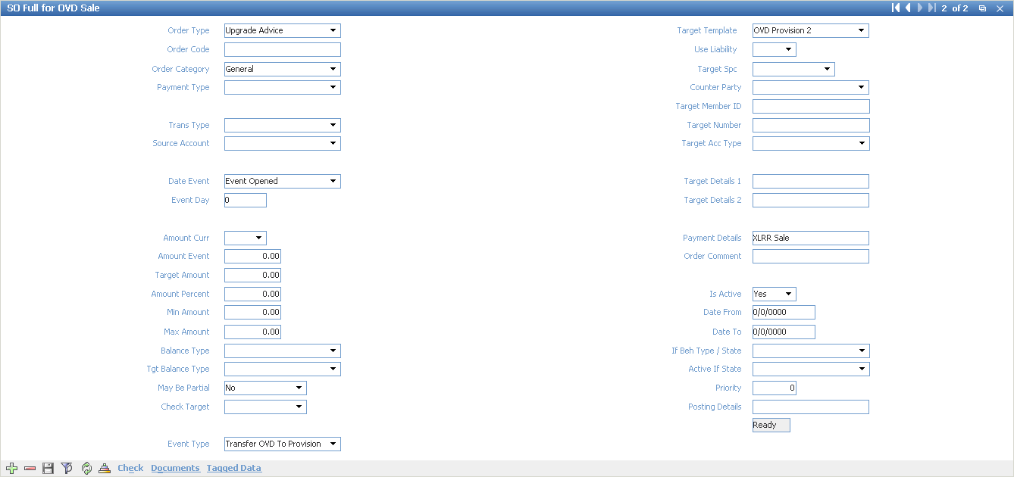

* + - Click “Save form changes”
  + Select “OVD Cash” & Click “SO Full” 🡪 Open “SO Full for …”
    - Click “Insert new record”
    - Input values as below

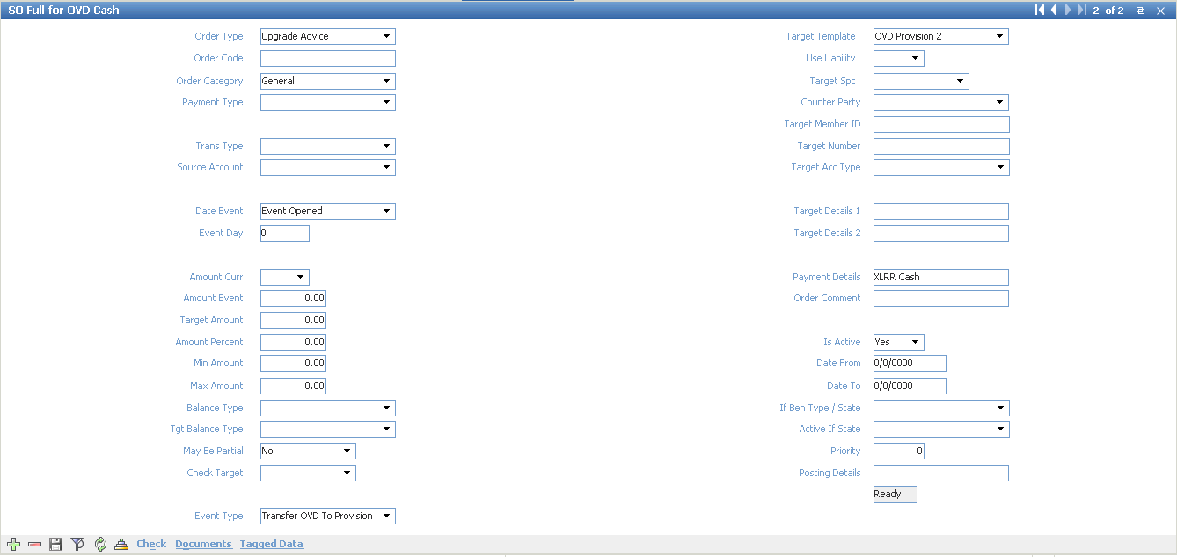

* + - Click “Save form changes”
  + Select “OVD Sale Interest” & Click “SO Full” 🡪 Open “SO Full for …” form
    - Click “Insert new record”
    - Input values as below image

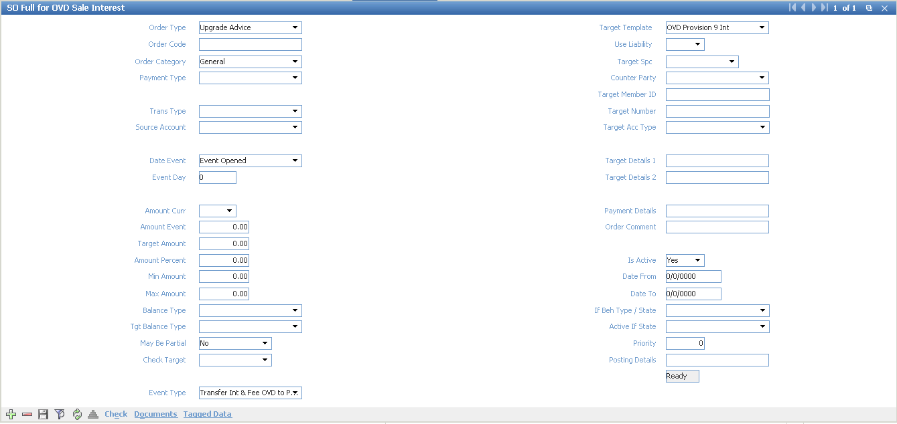

* + - Click “Save form changes”
  + Select “OVD Cash Interest” & Click “SO Full” 🡪 Open “SO Full for …” form
    - Click “Insert new record”
    - Input values as below image

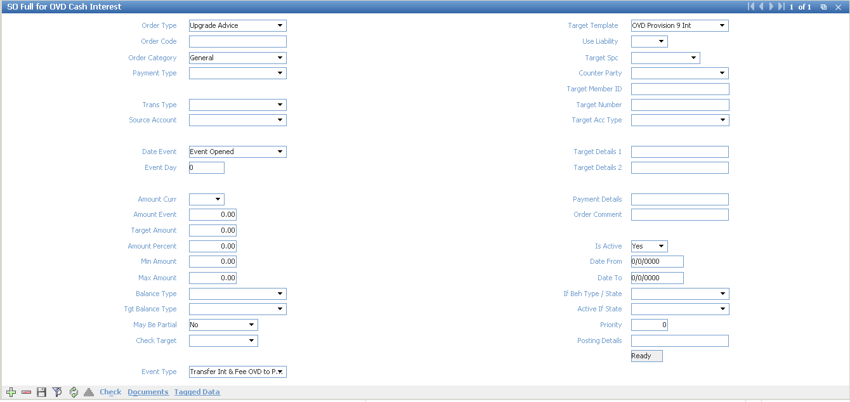

* + - Click “Save form changes”
  + Select “OVD Late Payment Fee” & Click “SO Full” 🡪 Open “SO Full for …” form
    - Click “Insert new record”
    - Input values as below image

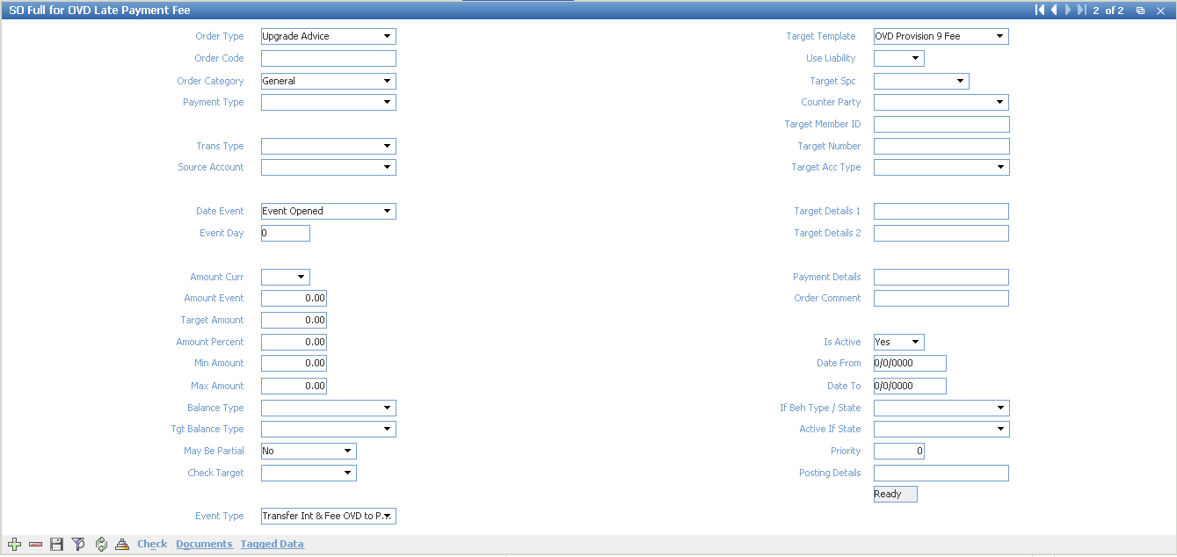

* + - Click “Save form changes”
  + Select “OVD Late Payment Fee”
    - Update values
      * GL Number: Phi the tin dung chua thu duoc (9410) - NEW-VND194441100.BBBB
    - Click “Save form changes”
  + Select “OVD Provision 9 Fee”
    - Update values:
      * GL Number: TK Ao ngoai bang (9)-VND199950001.BBBB
    - Click “Save form changes”
  + Select “OVD Provision 9 Int”
    - Update values:
      * GL Number: TK Ao ngoai bang (9)-VND199950001.BBBB
    - Click “Save form changes”
  1. Setup account scheme for balance transfer
* Select “Local Credit CashCard Account”, “JCB Credit Private Account”, “MasterCard Credit Private Account” & Click “Definition” 🡪 Open “Definition for …” form
  + Click “Insert new record”
  + Input values
    - Curr: VND
    - Account Type: Open Cash Interest
    - Account Name: Open Cash Interest
    - Is Am Available: No
    - GL Type: Balance
    - GL Number: TK Thu nhap lai-VND183371002.BBBB
  + Click “Save form changes”
  + Click “Full Info” 🡪 Open “Full Info for …” form
    - Update values as below images

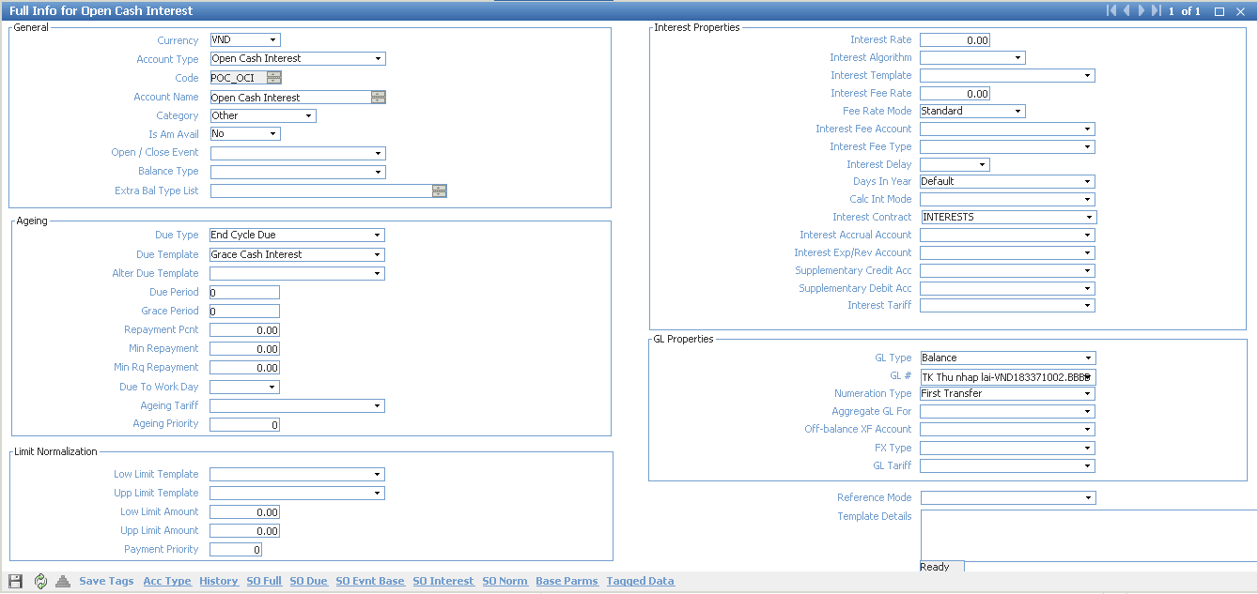

* + - Click “Save form changes”
  + Click “Insert new record”
  + Input values
    - Curr: VND
    - Account Type: Open Sale Interest
    - Account Name: Open Sale Interest
    - Is Am Available: No
    - GL Type: Balance
    - GL Number: TK Thu nhap lai-VND183371002.BBBB
  + Click “Save form changes”
  + Click “Full Info” 🡪 Open “Full Info for …” form
    - Update values as below images

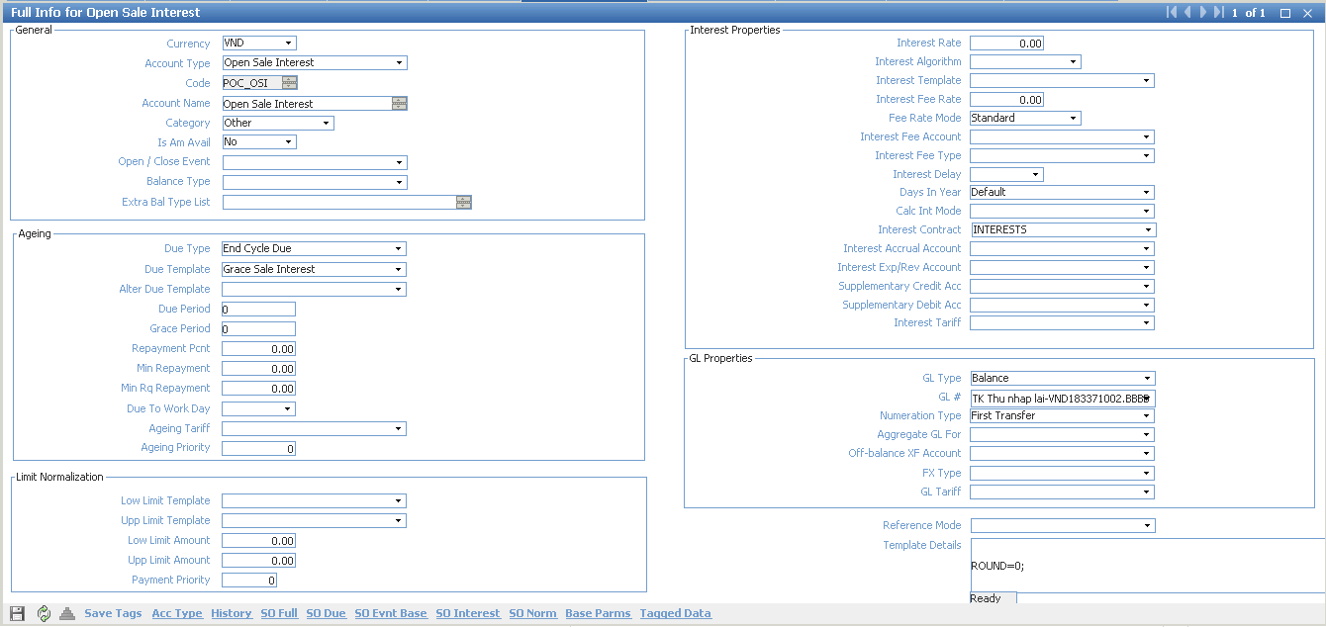

* + - Click “Save form changes”
  1. Setup account scheme for OCB TELLER
* Select “Teller BAcc Scheme” & Click “Definition” 🡪 Open “Definition for ..” form
  + Click “Insert new record”
  + Input values
    - Curr: VND
    - Account Type: Incoming Active
    - Account Name: Incoming Active
    - Is Am Available: No
    - GL type: Balance
    - GL Number: TK Misc-VND1757610010001
  + Click “Save form changes”
  + Click “Insert new record”
  + Input values
    - Curr: VND
    - Account Type: Incoming Passive
    - Account Name: Incoming Passive
    - Is Am Available: No
    - GL type: Balance
    - GL Number: TK Misc-VND1757610010001
  + Click “Save form changes”
  + Click “Insert new record”
  + Input values
    - Curr: VND
    - Account Type: Incoming Active Cashback
    - Account Name: Incoming Active Cashback
    - Is Am Available: No
    - GL type: Balance
    - GL Number: TK Cashback-VND1260110120001
  + Click “Save form changes”
  + Click “Insert new record”
  + Input values
    - Curr: VND
    - Account Type: Incoming Passive Cashback
    - Account Name: Incoming Passive Cashback
    - Is Am Available: No
    - GL type: Balance
    - GL Number: No GL VND-911111111
  + Click “Save form changes”
  + Click “Insert new record”
  + Input values
    - Curr: VND
    - Account Type: Incoming Active Chargeback - JCB
    - Account Name: Incoming Active Chargeback - JCB
    - Is Am Available: No
    - GL type: Balance
    - GL Number: TK Chargeback JCB-VND1754410010001
  + Click “Save form changes”
  + Click “Insert new record”
  + Input values
    - Curr: VND
    - Account Type: Incoming Active Chargeback - MC
    - Account Name: Incoming Active Chargeback - MC
    - Is Am Available: No
    - GL type: Balance
    - GL Number: TK Chargeback MC-VND1754310010001
  + Click “Save form changes”
  + Click “Insert new record”
  + Input values
    - Curr: VND
    - Account Type: Incoming Active Chargeback - NAPAS
    - Account Name: Incoming Active Chargeback - NAPAS
    - Is Am Available: No
    - GL type: Balance
    - GL Number: TK Chargeback NAPAS-VND1754710010001
  + Click “Save form changes”
  + Click “Insert new record”
  + Input values
    - Curr: VND
    - Account Type: Incoming Active Chargeback - VS
    - Account Name: Incoming Active Chargeback - VS
    - Is Am Available: No
    - GL type: Balance
    - GL Number: TK Chargeback VS- VND1754610010001
  + Click “Save form changes”
* Approve “Local Credit CashCard Account”, “JCB Credit Private Account”, “MasterCard Credit Private Account”, “Teller BAcc Scheme”

1. Setup instalment

* Navigate ROOT\OpenWay\Instalments\Instalment Configuration\Instalment Scheme Groups\Available Instalment Balance
* Click “Insert new record”
* Input values
  + Instalment Scheme Group: OCB Installment
  + Balance Type: INST_C
* Click “Save form changes”